1.Check the variable

#!/bin/bash

count=100
if [ $count -eq 100 ]
then
echo Count is 100
else
echo Count is not 100
fi



2.Check if a file error.txt exist

#!/bin/bash

clear
if [ -e /home/iafzal/error.txt ]

then
echo "File exist"
else
echo "File does not exist"
fi



3.Check if a variable value is met

#!/bin/bash

a=`date | awk '{print $1}'`

if [ "$a" == Mon ]

then
echo Today is $a
else
echo Today is not Monday
fi

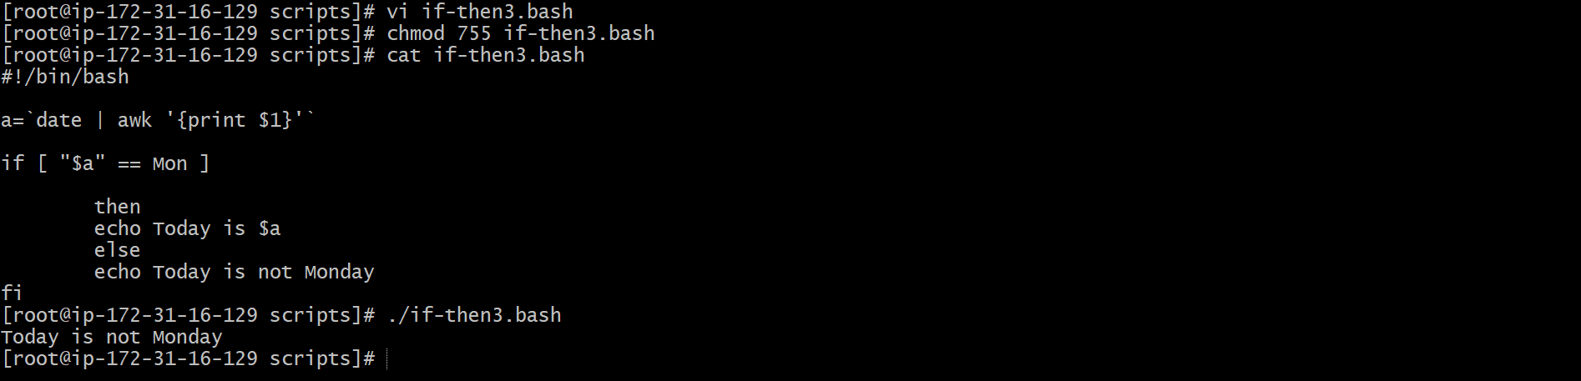

4.Check the response and then output

#!/bin/bash

clear
echo
echo "What is your name?"
echo
read a
echo

echo Hello $a sir
echo

echo "Do you like working in IT? (y/n)"
read Like
echo

if [ "$Like" == y ]
then
echo You are cool

elif [ "$Like" == n ]
then
echo You should try IT, it’s a good field
echo
Fi



